**String Theory**

***bin***

**Challenge:**

I recieved this very weird email that only contained a file called "openme", it looks like an executable.

Can you see if there is anything weird in this file?

Attached - openme

**Approach:**

Easy question, we just run the strings command on it with grep to find the possible flag:

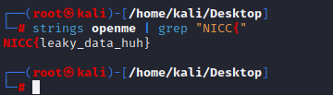

**Flag: NICC{leaky_data_huh}**

Congrats!!

Happy Hacking!